(Approx. 1,263 words)

2TB of Cloud Storage - Free!
By Phil Sorrentino, Past President, Sarasota PCUG, Florida
January 2014 issue, PC Monitor
www.spcug.org
philsorr (at) yahoo.com

Well, now that I have your attention, let me tell you how you can accomplish this without any trickery or dishonesty. (Remember, 1TB is equal to 1,000 GB) Wouldn’t it be nice to have all of your pictures, videos and documents available to you whenever and wherever you want it? Cloud storage is a great way to accomplish this. Cloud storage is available from many sources like Skydrive, Google Drive, SugarSync, Dropbox, etc. Some of these cloud services give you from 2GB to 7GB of free storage and then you pay for additional space (Skydrive provides 7GB free). With over 100GB of pictures and more than double that amount of videos, this could run into quite an expense using one of the commercial cloud storage services.

The cloud service I’m suggesting is your own computer system with an additional external (or internal) 2TB hard drive. You don’t have to use a 2TB drive if you don’t need that much storage. Maybe you have an old 300 or 500GB hard drive around that would do the trick. The size of the drive is not that important. What is important is that the information on that drive will be available to you wherever you are. The software that makes this incredible benefit possible is called Teamviewer. Teamviewer is available for your PC, and the Teamviewer App is available for your smartphone and/or tablet; both the PC software and the App are free for personal use. (Though the App can work on a smartphone, a 4 or 5 inch display is really too small. If you try this on a smartphone, I think you will find that the objects you will want to control will be too small when you try to use your finger to select these objects. It really works well on a larger display, so I will be limiting my discussion to a tablet with at least a 7 or 8 inch display. It works great on a 10 inch display.)

For this arrangement to work, you install Teamviewer on your home computer, you install the Teamviewer App on to your tablet, and then you leave your home computer on whenever you want access to it and the hard drive. Because I’ve limited this to tablets, the tablet will have to be in reach of a Wi-Fi network because most tablets only have Wi-Fi. Wi-Fi networks are typically found in many places such as homes, airports, libraries, Starbucks, Panera Bread, shopping centers, and some McDonalds.) If your tablet has cell phone capability then you don’t have this restriction.

Teamviewer is a software package used for remote control, desktop sharing, online meetings, web conferencing, and file transfer between computers. It runs on Windows, Apple and Android operating systems. The basic features of Teamviewer are similar to Crossloop. (You might remember Crossloop from an article published in the Sarasota PC Users Group Monitor in Feb. 2010. The intent of that article was “Assisting another member with a computer problem”, but if you’ll remember it was stated that “CrossLoop provides a quick, easy, and completely free way to give another member, a friend, or a relative, access to your computer”. This remote control feature is also part of Teamviewer, and Teamviewer has the App for tablets that allows these devices to act as remote controllers. As it says on the Teamviewer website, “Teamviewer allows you to control computers remotely via the internet, as if you were sitting right in front of them”. The home computer desktop appears on the tablet and you can interact with your home computer by using various touch-screen gestures to control the home computer and its software. Just start Windows explorer on your tablet with a double tap, (once your home computer desktop appears on the tablet) and then navigate to the Drive you have designated as “Cloud Storage”, and navigate to the folders and files of interest. To show a picture, just double tap on the file in question. You can even start a video or music and it will be streamed to your tablet, for your enjoyment. (The video will only be acceptable if you have a fast uplink at home.)

To download Teamviewer for your computer, just go to www.teamviewer.com and click on the Download button. To download the Teamviewer App for your Android tablet, just go to the Google Play Store and touch the Magnifying Glass to search for “Teamviewer”, and then download the App. The Teamviewer App logo is as shown here:
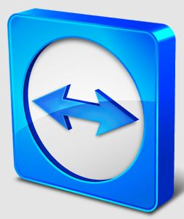
Teamviewer Logo

After Teamviewer has been installed on your PC, start it and you will be presented with a window that gives you a “Your ID” and a “Password” for this Computer. This ID is what you will need when you are attempting to remotely control this PC. (The “Partner ID” would be used if you were going to attempt to control another PC from this PC. That might be the subject of another article.) The last item needed is the “Personal Password”. You can use the “Setup unattended access” wizard by clicking on the pencil icon in the Personal Password box, or you can just assign a personal password by entering a password that you desire into the Personal Password box. I would suggest you use the wizard, at least the first time. Once you have the Personal Password setup you are ready to allow remote control, or Unattended Access, as the wizard calls it.

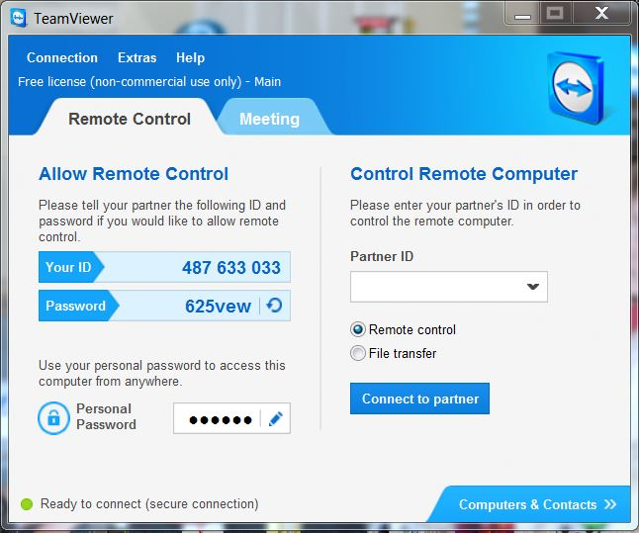
Teamviewer on the PC

The last thing to do is set up the tablet for remote control, or “unattended access of the PC”. After the Teamviewer App is installed on the tablet, start it by tapping it’s icon. This will bring up the Teamviewer remote control screen. Enter the “Your ID” number that was assigned to your PC and tap Remote Control. Teamviewer will make a connection with your PC and display an Authentication window (if it doesn’t, your tablet may not be on the Wi-Fi network). Enter your “Personal Password” into the password box and tap OK. The first time this is done you will see a screen of Touch interactions as a primer for tablet control; just tap Continue (and check the “Don’t show this dialog again” if you don’t want to see this screen again.) After you tap Continue, your PC desktop will appear on your tablet. There is a box on the bottom right that indicates you are using Teamviewer; flick the box to the right so it will be out of your way. Now you can operate your computer just as if you were sitting in front of it. The only difference is that there is no keyboard, but you can use the tablet virtual keyboard by taping on the keyboard icon on the bottom towards the left, whenever it is needed.

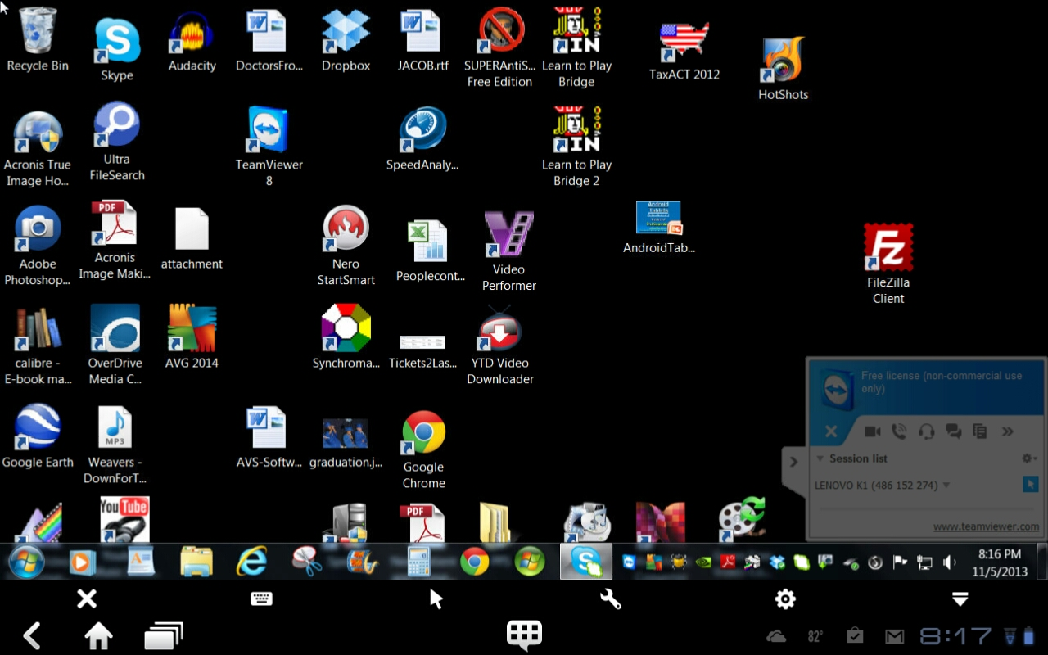
Tablet showing the PC Desktop

Now to get to your data, just open the Windows Explorer and navigate to the drive and open any of the folders and files that are now part of your 2TB cloud storage. Make sure you close everything and save any changes you made before leaving Teamviewer. To leave Teamviewer and close the connection, tap the big X on the bottom left, and then go back to your home screen.

Now, how is that for 2TB of cloud storage with no monthly storage charge?
(I’d like to thank Dennis Russell, a student in my Android Tablets class, for making me aware of Teamviewer.)

